Name of Student: HARPAL BIDAWAT | PRN:25070122080
Semester: III | Year : AY 2026-27
Subject: Programming with Java
ASSIGNMENT No : 24
TITLE : JDBC with GUI
Problem Statement
Develop a Java GUI application integrated with JDBC to perform database operations."
Learning Objectives
To integrate Java GUI applications with databases using JDBC.

Programme
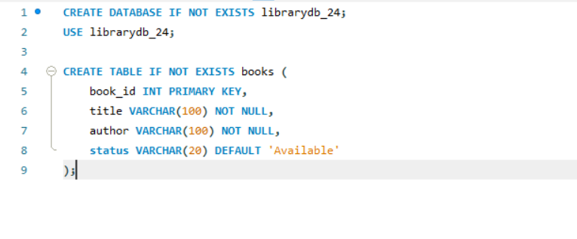

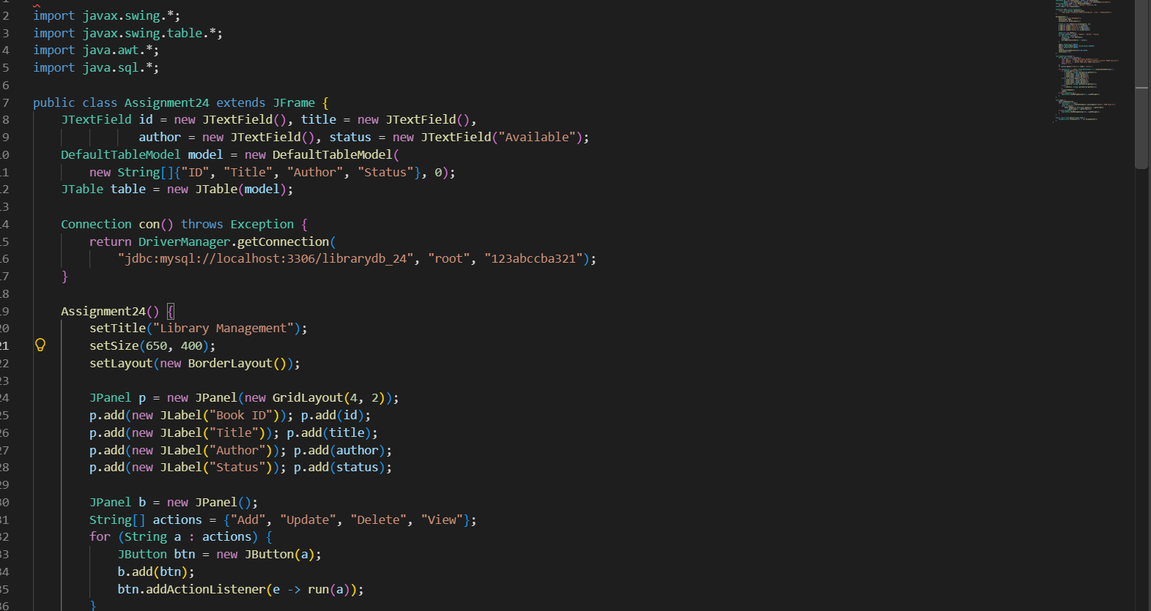
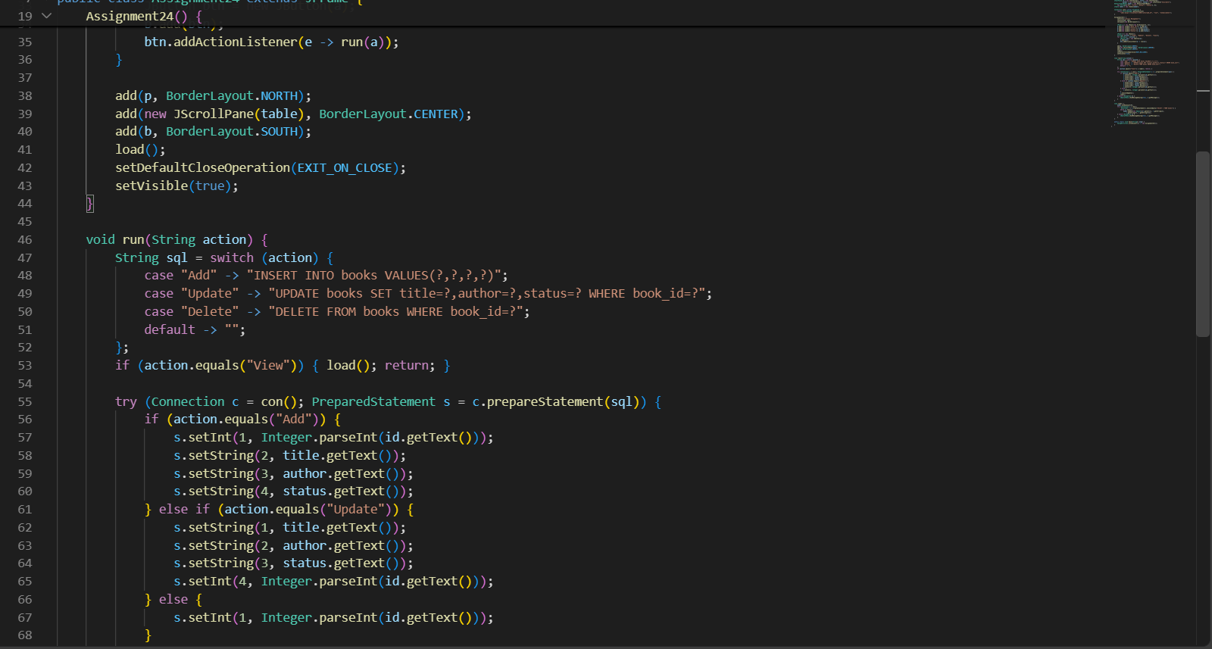
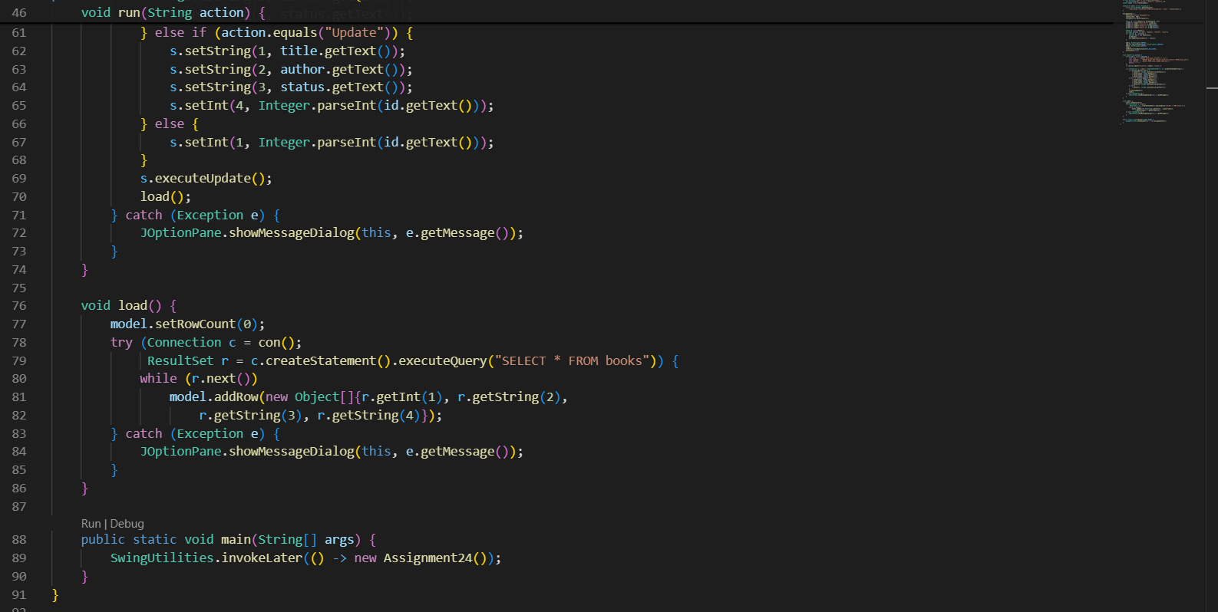
Output

Add and view-
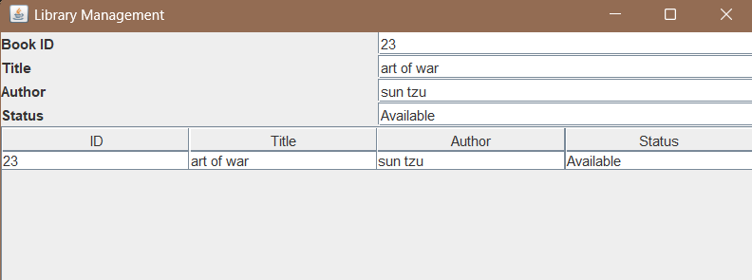
Update and view -
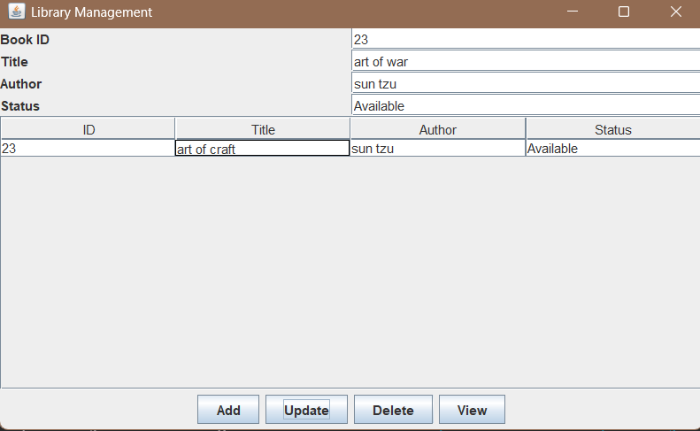
delete and view -
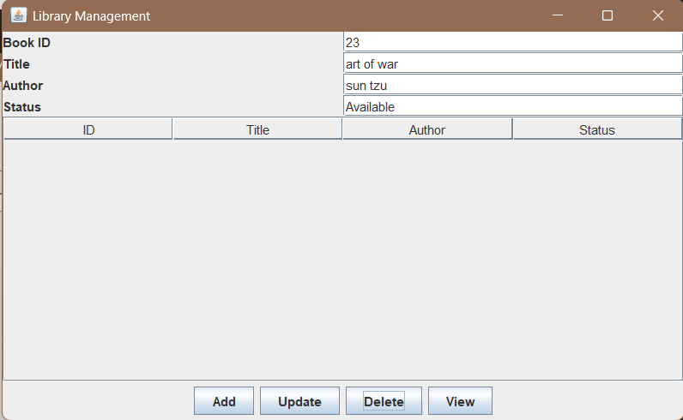

Conclusion

